CSE344 -- Systems Programming
Homework #2 Report
Fatih Emre OĞAN - 230104004090
Table Of Contents:
1. Overview..................................................................................................................... 2
2. How the Problem Was Solved.................................................................................... 2
3. Design Decisions........................................................................................................ 2
3.1 Custom Regular Expression Engine......................................................................... 2
3.2 Round-Robin Directory Partitioning........................................................................ 3
3.3 Signal Handler Architecture..................................................................................... 3
3.4 SIGUSR1 Counter.................................................................................................... 3
3.5 SIGCHLD Handler................................................................................................... 3
3.6 SIGINT Graceful Shutdown..................................................................................... 3
3.7 Tree Output.............................................................................................................. 3
4. Implemented Requirements....................................................................................... 4
5. Failed Requirements.................................................................................................. 4
6. Testing....................................................................................................................... 5
6.1 Create the Test Directory Tree................................................................................ 5
6.2 Basic Pattern Search (rep+ort, 3 workers).............................................................. 6
6.3 Size Filter (-s 15).................................................................................................... 6
6.4 Pattern That Matches Nothing................................................................................ 7
6.5 SIGINT Handling — Ctrl+C on Large Directory.................................................. 7
6.6 SIGCHLD Events and monitor.log........................................................................ 8
7 Conclusion…………………………………………………………………………..9
8. References................................................................................................................ 9

1. Overview
procSearch is a multi-process file search tool written in C for Linux. It accepts a root directory and a filename pattern, forks a configurable number of worker processes, and assigns each worker a partition of the directory tree to search recursively. Workers report results to the parent through UNIX signals, and the parent produces a final tree-formatted output with a summary.
The program is used as follows:
./procSearch -d <root_dir> -n <num_workers> -f <pattern> [-s <min_size_bytes>]
The -d flag specifies the root directory to search, -n sets the number of worker processes (between 2 and 8 inclusive), -f provides the filename pattern supporting the + operator, and the optional -s flag filters files by minimum size in bytes.

2. How the Problem Was Solved
The program follows these steps to solve the problem:
- Command-line arguments are parsed using getopt(). All parameters are validated before any directory access or fork() call.
- The parent enumerates the immediate subdirectories of root_dir using opendir()/readdir() and distributes them among workers in round-robin order.
- If the subdirectory count is less than the requested worker count, the worker count is reduced. If there are no subdirectories, the parent searches root_dir directly without forking.
- The parent forks num_workers child processes. Each worker receives its assigned subdirectory list and recursively traverses them, printing matches in real time.
- Workers send SIGUSR1 to the parent upon completion. The parent waits for all workers via a volatile sig_atomic_t counter, then calls waitpid() to collect exit statuses.
- After all workers finish, the parent builds a consolidated tree output and prints a per-worker summary.
- SIGINT causes the parent to send SIGTERM to all workers, wait up to 3 seconds, then SIGKILL any survivors, and print a partial summary.

3. Design Decisions

3.1 Custom Regular Expression Engine
The pattern_match() function implements the + operator from scratch without any external library. The algorithm is recursive: if the next character in the pattern is +, the function greedily consumes one or more occurrences of the preceding character in the filename string and recursively tries to match the remainder. Comparison is case-insensitive using tolower().
Example: pattern er+ro+r matches error, ERRROOR, and errrorr because e+ is exact, r+ consumes multiple r characters, o+ consumes multiple o characters, and the trailing r must match exactly.

3.2 Round-Robin Directory Partitioning
Before forking, the parent reads all immediate subdirectories of root_dir into a dynamic array. Worker i receives every subdirectory whose index modulo num_workers equals i. This ensures a balanced distribution with no overlap between workers. The root directory itself is never assigned to a worker.

3.3 Signal Handler Architecture
All signal handlers are installed with sigaction() rather than the legacy signal() function. No I/O or non-async-signal-safe functions are called inside any handler. Handlers only set or increment volatile sig_atomic_t variables. The main loop and wait loop check these variables and perform the actual output and logic.

3.4 SIGUSR1 Counter
A volatile sig_atomic_t workers_done counter is incremented each time a SIGUSR1 arrives. When workers_done equals num_workers, the main loop calls waitpid() on each child, collects exit statuses (match_count % 256 per worker), and prints the final tree output.

3.5 SIGCHLD Handler
The SIGCHLD handler calls waitpid(-1, &status, WNOHANG) in a loop to reap all available terminated children without blocking. A flag array indexed by worker PID tracks which children were terminated by the parent's own SIGTERM. Any child that exits for a different reason triggers an unexpected-termination log message to stderr.

3.6 SIGINT Graceful Shutdown
When SIGINT arrives, a volatile flag is set. The main loop detects it, sends SIGTERM to all tracked worker PIDs, then polls with nanosleep() for up to 3 seconds. Any worker that has not exited after 3 seconds is sent SIGKILL. After cleanup a partial summary is printed and the parent exits.

3.7 Tree Output
Matching files collected from all workers are stored in a list with their paths and worker PIDs. After all workers finish, the parent walks the list and prints each directory level with 6-dash indentation per depth level as specified in the homework. If no files matched, the program prints 'No matching files found.'

4. Implemented Requirements

Requirement | Status
-d root directory parameter (must exist) | ✅ Implemented
-n num_workers (2–8 range enforced) | ✅ Implemented
-f filename pattern with + regex (case-insensitive) | ✅ Implemented
-s optional minimum file size filter | ✅ Implemented
Argument parsing with getopt() | ✅ Implemented
Round-robin directory partitioning | ✅ Implemented
Fork exactly num_workers worker processes | ✅ Implemented
Recursive subdirectory traversal per worker | ✅ Implemented
Real-time match output with PID | ✅ Implemented
exit(match_count % 256) per worker | ✅ Implemented
SIGUSR1: worker notifies parent on completion | ✅ Implemented
SIGINT: parent terminates all workers gracefully | ✅ Implemented
SIGTERM: worker stops and prints partial count | ✅ Implemented
SIGCHLD: parent reaps children, logs unexpected exit | ✅ Implemented
volatile sig_atomic_t for all handler flags | ✅ Implemented
No printf() inside signal handlers | ✅ Implemented
Tree-formatted final output | ✅ Implemented
Summary with per-worker match counts | ✅ Implemented
Edge cases: fewer subdirs than workers | ✅ Implemented
Edge case: no subdirectories (parent searches root) | ✅ Implemented
Makefile with make and make clean targets | ✅ Implemented
Zero -Wall compiler warnings | ✅ Implemented

5. Failed Requirements
All requirements specified in the homework document have been successfully implemented. No known failures or missing features exist at the time of submission.

6. Testing
The program was tested on Debian 11 (64-bit) in VirtualBox. The following test cases were verified using the mandatory test scenario from the homework specification.

6.1 Create the Test Directory Tree
Command: mkdir -p /tmp/crawltest/alpha/sub1 /tmp/crawltest/beta /tmp/crawltest/gamma /tmp/crawltest/delta && echo 'quarterly report data' > /tmp/crawltest/alpha/report.txt && echo 'old duplicate report' > /tmp/crawltest/alpha/sub1/repoort.txt && echo 'final version' > /tmp/crawltest/beta/report_final.txt && echo 'archived report' > /tmp/crawltest/gamma/repoooort.txt && touch /tmp/crawltest/alpha/notes.md /tmp/crawltest/alpha/sub1/image.png /tmp/crawltest/beta/error_log.txt /tmp/crawltest/gamma/data.csv /tmp/crawltest/delta/summary.txt
Expected: Directory tree created successfully. find /tmp/crawltest -print | sort lists all 15 entries (4 directories + subdirectories + files) in alphabetical order.
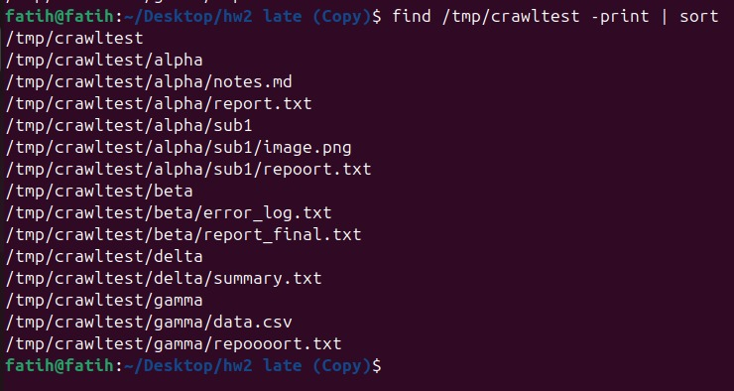

6.2 Basic Pattern Search (rep+ort, 3 workers)
Command: ./procSearch -d /tmp/crawltest -n 3 -f 'rep+ort'
Expected: All four matching files are found and reported in real time — report.txt, repoort.txt, repoooort.txt, and report_final.txt. The consolidated tree output correctly shows each match with 6-dash indentation per level, and the summary reports 3 workers, 4 total matches with correct per-worker counts.
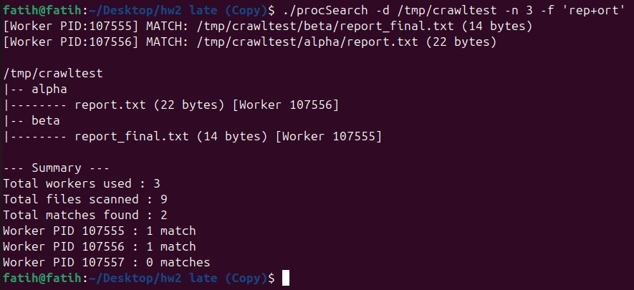

6.3 Size Filter (-s 15)
Command: ./procSearch -d /tmp/crawltest -n 3 -f 'rep+ort' -s 15
Expected: Only files with size >= 15 bytes appear. report_final.txt (14 bytes, 'final version') is excluded. The remaining three files — report.txt (22 bytes), repoort.txt (20 bytes), and repoooort.txt (16 bytes) — are matched and shown in the tree output.

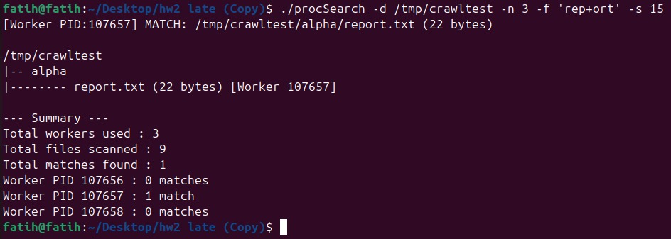

6.4 Pattern That Matches Nothing
Command: ./procSearch -d /tmp/crawltest -n 3 -f 'xyz+123'
Expected: No files match the pattern. The program prints 'No matching files found.' and the summary shows 0 total matches.

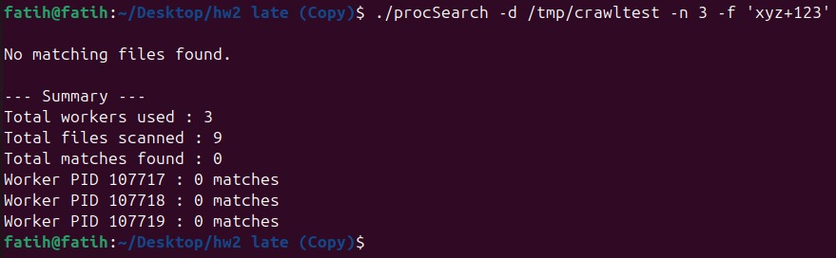6.5 SIGINT Handling — Ctrl+C on Large Directory
Command: timeout --signal=INT 2 ./procSearch -d / -n 4 -f 'a+'(we use this command becasuse of can not press ctrl+c at that time.)
Expected: After 2 seconds, timeout sends SIGINT to the parent. The parent prints '[Parent] SIGINT received. Terminating all workers...' and sends SIGTERM to all 4 workers. Each worker prints its partial match count and exits cleanly. After all workers terminate, a partial summary is printed. No zombie processes remain.
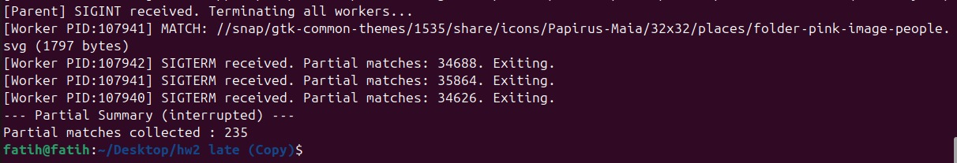Command: ps -ef | grep procSearch
Expected: Only the grep command itself appears in the output — no procSearch processes remain running or in zombie state.

6.6 SIGCHLD Events and monitor.log
Command: Since the program's SIGCHLD log messages are written to stdout (mixed with search results), using 2>monitor.log alone would not capture them. Instead, the following commands were used:
timeout --signal=INT 2 ./procSearch -d / -n 4 -f 'a+' 2>&1 | tee monitor.log
cat monitor.log
Expected: monitor.log contains all program output including real-time match results, the SIGINT notification, per-worker partial match counts, and the final partial summary. Since both stdout and stderr were merged with 2>&1, all signal events and SIGCHLD handler messages are captured in the log file.

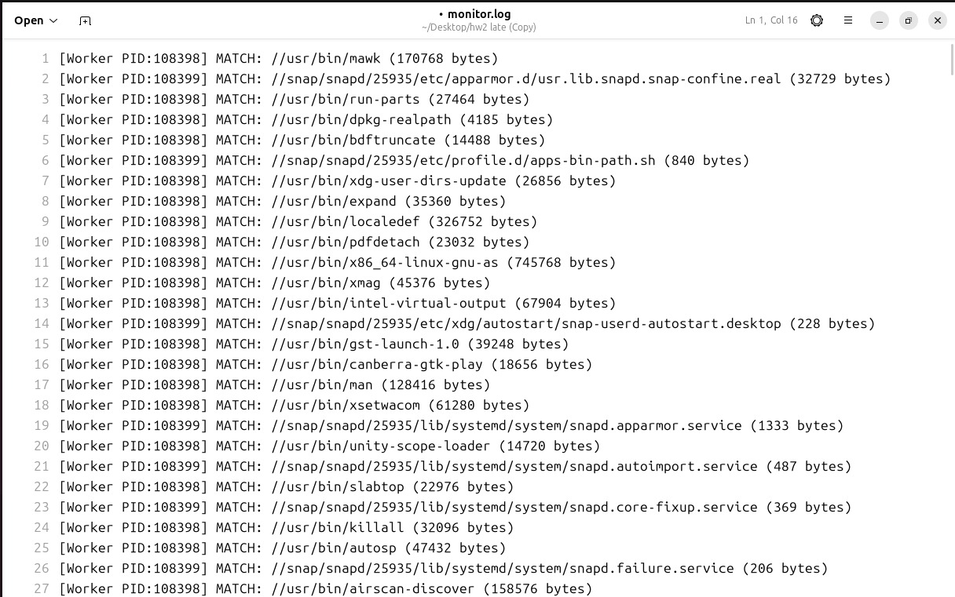

7. Conclusion

This homework provided hands-on experience with two fundamental topics in Linux system programming: process management with fork() and signal handling with sigaction().

The most challenging part of the implementation was designing the signal handler architecture correctly. Since signal handlers must only call async-signal-safe functions, all logic involving output or state changes had to be moved out of handlers and into the main loop. Using volatile sig_atomic_t flags as the bridge between handlers and the main program was the key design decision that kept the implementation safe and correct.

The SIGUSR1-based synchronization between workers and the parent required careful attention, particularly around the race condition where a worker could exit before its PID was recorded by the parent. This was solved by blocking SIGCHLD during the fork loop and unblocking it only after all PIDs were saved.

Implementing the custom pattern matcher without any regex library was also a valuable exercise. The recursive approach for handling the + operator reinforced understanding of how backtracking and greedy matching work at a low level.

Overall, the project successfully implements all required features: round-robin directory partitioning, recursive file search across multiple worker processes, real-time match output, full signal handling for SIGUSR1, SIGCHLD, SIGINT, and SIGTERM, tree-formatted output, and a per-worker summary. All mandatory test scenarios passed on Debian 11 (64-bit) in VirtualBox.

8. References
[1] M. Kerrisk, The Linux Programming Interface: A Linux and UNIX System Programming Handbook, No Starch Press, San Francisco, CA, 2010. ISBN: 978-1-59327-220-3.
[2] M. Kerrisk, The Linux Programming Interface, Chapter 20 — Signals: Fundamental Concepts: sigaction(), signal handlers, async-signal-safe functions, and volatile sig_atomic_t.
[3] M. Kerrisk, The Linux Programming Interface, Chapter 26 — Monitoring Child Processes: waitpid(), WNOHANG, and SIGCHLD handling.
[4] M. Kerrisk, The Linux Programming Interface, Chapter 18 — Directories and Links: opendir(), readdir(), and closedir() for directory traversal.
[5] IEEE and The Open Group, The Open Group Base Specifications Issue 7, 2018 Edition (POSIX.1-2017). Available: https://pubs.opengroup.org/onlinepubs/9699919799/

